1.Draw the following on the triangle below.  
  
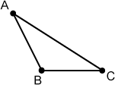  
  
a)   Perpendicular Bisector from segment .  
  
b)   Angle bisector from vertex A.  
  
c)   Median from vertex A.  
  
d)   Altitude from vertex A.  
  
e)   Mid-Segment parallel to line segment .

2.Draw the following on the triangle below.  
  
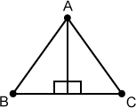  
  
a)   Perpendicular Bisector from segment .  
  
b)   Angle bisector from vertex A.  
  
c)   Median from vertex A.  
  
d)   Altitude from vertex A.  
  
e)   Mid-Segment parallel to line segment .

For problems #3 - #16, determine if the segment  is:   a perpendicular bisector, angle bisector, median, altitude or mid-segment

3.  
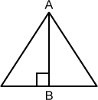

4.  
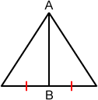

5.  
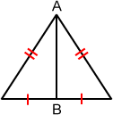

6.  
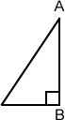

7.  
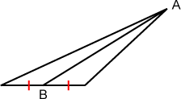

8.  
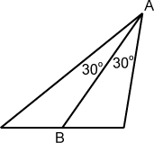

9.  
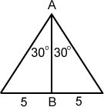

10.  
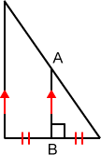

11.  
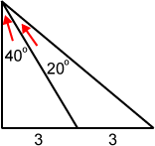

12.  
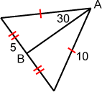

13.  
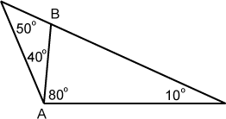

14.  
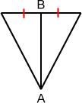

15.  
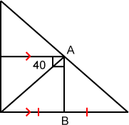

16.  
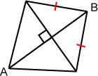

Find the following:

17.Given A(-5, 10), B(8, 7) and C(-4, -8) are vertices of triangle ABC, find the following:  
  
a.   What are the coordinates of K, if  is a median of triangle ABC?  
  
b.   What is the slope of  if  is the altitude from vertex C?  
  
c.   Point N on  has coordinates (8  
, 20  
).   Is  an altitude of triangle ABC?  
  
d.   Point N on  has coordinates (180  
, 102  
).   Is  an altitude of triangle ABC?

18.Given A(-8, 7), B(6, 13) and C(-3, -11) are vertices of triangle ABC, find the following:  
  
a.   What are the coordinates of K, if  is a median of triangle ABC?  
  
b.   What is the slope of  if  is the altitude from vertex C?  
  
c.   Point N on  has coordinates (168  
, 229  
).   Is  an altitude of triangle ABC?  
  
d.   Point N on  has coordinates (5  
, 102  
).   Is  an altitude of triangle ABC?

19.Given A(-3, 7), B(-5, -17) and C(4, 10) are vertices of triangle ABC, find the following:  
  
a.   What are the coordinates of K, if  is a median of triangle ABC?  
  
b.   What is the slope of the perpendicular bisector of ?  
  
c.   Point N on  has coordinates (12  
, 26  
).   Is  an altitude of triangle ABC?  
  
d.   Point N on  has coordinates (-2  
, -8  
).   Is  an altitude of triangle ABC?

20.Given A(-6, 8), B(-9, -4) and C(6, 6) are vertices of triangle ABC, find the following:  
  
a.   What are the coordinates of K, if  is a median of triangle ABC?  
  
b.   What is the slope of the perpendicular bisector of ?  
  
c.   Point N on  has coordinates (3  
, 9  
).   Is  an altitude of triangle ABC?  
  
d.   Point N on  has coordinates (-18  
, 14  
).   Is  an altitude of triangle ABC?

Use the Triangle Inequality to determine if it is possible to draw a triangle with the given measures as sides:

21.215, 204, 7

22.1, 2, 3

23.16, 12, 17

24.2.5, 6, 6.5

25.2.2, 12, 14.3

26.3.9, 8.4, 15.6

Use the Triangle Inequality to complete the following:

|  |  |  |  |
| --- | --- | --- | --- |
| First side measure: | Second side measure: | Third side is greater than: | Third side is less than: |
| 27. 3 | 7 | ? | ? |
| 28. 10 | 6 | ? | ? |
| 29. 15 | 12 | ? | ? |
| 30. 13 | ? | 6 | 32 |

Prove the following:

31.Prove Theorem 2.1.2:  
If the mid-segment is drawn in a triangle, then it is parallel to the side that is not included in the mid-segment.

32.Prove Theorem 2.1.3:  
If the mid-segment is drawn in a triangle, then it is half the length of the side not included in the mid-segment.